Experiment 1

Name:- BABBULA NISHANTH

Roll No.:- 2320030119

Creating a simple network between 2 PC’s using ping command

Step by step procedure:-

Step1:- Open cisco packet tracer.

Step 2:- Create a simple network.

Step 3:- Add 2 PC’s and connect with copper straight through cable.

Step 4:- Give IP address

PC1 desktop IP address

PC1=192.168.1.1

PC2 desktop IP address

PC2=192.168.1.2

Step 5:- PC2 desktop Command prompt and write command

ping <IP address of PC1>

Diagram:

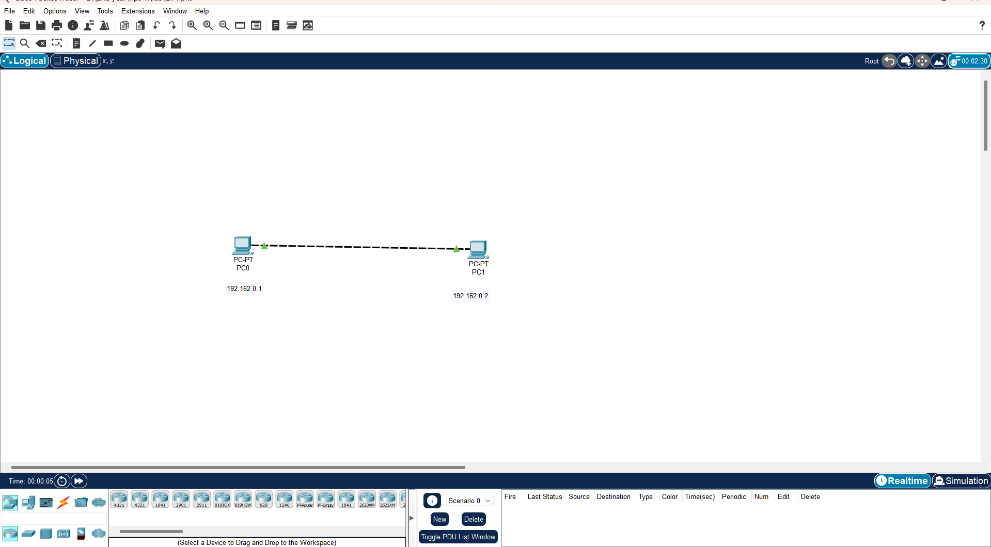

Result:-

We have connected the 2 PC’s and now can send packets from one PC to another.

